Jonathan Hess

Section 3.1

## Week 6 Lab Report: Basic Circuits (I)

# Lab Report Rubric

|  |  |  |
| --- | --- | --- |
| **Category** | **Student Score** | **Grader Score** |
| **Organization** | | |
| **Appropriate sections** | **1/1** | **/1** |
| **Appearance and formatting** | **2/2** | **/2** |
| **Spelling, grammar, sentence structure** | **1/1** | **/1** |
| **Work** | | |
| **Experimental procedure** | **1.5/2** | **/2** |
| **Results (data, code, figure, graph, tables, etc.)** | **1/2** | **/2** |
| **Conclusion** | **1.5/2** | **/2** |
|  |  |  |
| **Total** | **8/10** | **/10** |

# Introduction

This week we started working on circuits and using basic resistors. We were told to measure the current, voltage and resistances of these resistors in different voltages and configurations.

# Procedure

**SPECIAL NOTE: I wrote down all my information on a looseleaf sheet of paper. When getting to writing this report I lost the sheet. I then decided to redo the lab with my own supplies.**

The first thing the lab asked for was to find the error on the resistors which I used the multimeter to calculate.

|  |  |  |
| --- | --- | --- |
| Resistor | Actual Value | Percent Difference |
| 1.1 Ohm (got from depot) | 1.2 ohms | 8% |
| 10 Ohm (mine) | 9.9 ohms | 1% |
| 100 Ohm (mine) | 100.6 ohms | .6% |

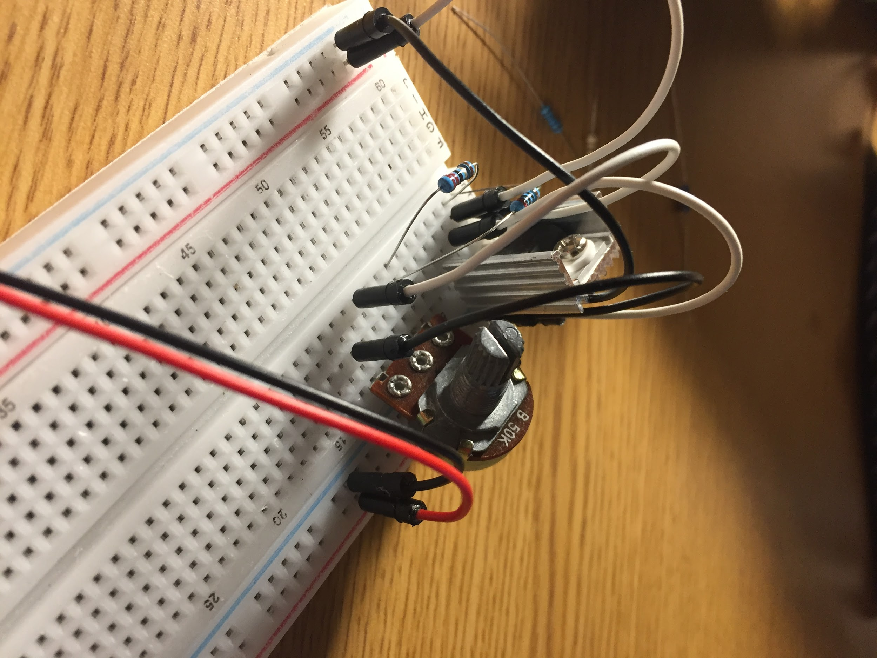

This is a basic variable power supply using a LM317 and a 50k potentiometer (that I switched with a 10k later)

I checked the amperage by tapping the multimeter to the leads of resistors (connected to Vo) while the other lead was connected to ground

The diagram for the circuit is below with one change.

white/black (on left) - positive and negative of regulated voltage (Vo)

red/black (on right) - positive and negative of base voltage (from 12 volt power supply) (Vi)

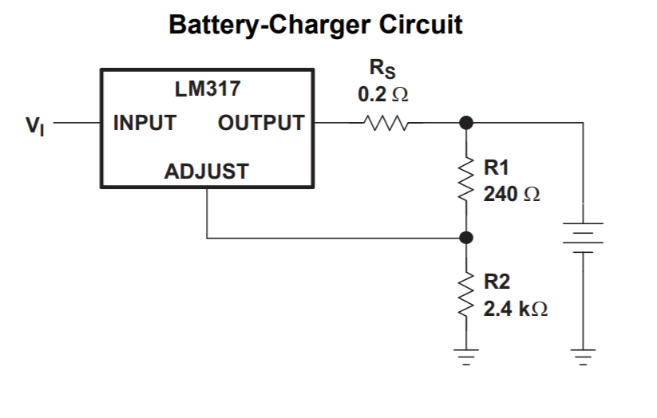

voltage divider circuit, replacing the 2.4k with potentiometer allows for variability

Sourced from reference sheet for lm317 (link bellow)

For the next part I had to get a stable voltage. One method would be to use a voltage divider. I decided against this because at the higher voltages it would be drawing too much current for a voltage divider to handle. Instead I used a LM317 (voltage regulator). Based on its specs, it should have a min voltage of 1.25 but it went down to 1.090 anyways.

<https://www.ti.com/lit/ds/symlink/lm317.pdf> - Reference sheet (also where circuit diagram is from)

Using a 12 volt power supply (for hard drive) that can provide 2A, I should not be limited by the power supply. The problem would be with the LM317’s output current being maximum 1.5 amps and the wires/breadboard.

|  |  |  |  |
| --- | --- | --- | --- |
| Voltage (V) | 1 ohm current (I) | 10 ohm current (I) | 100 ohm current (I) |
| 1.090 | .4 | .268 | .011 |
| 2 (1.88) | .773 | .773 | .019 |
| 3 (3.06) * | 1.2 | 1.2 | .03 |
| 4 (4.02) | 1.73 | 1.73 | .04 |
| 5(5.04) | 1.849 | 1.848 | .049 |
| 6(6.06) | 1.856 | 1.843 | .058 |

* replaced the 50k pot with 10k pot for better control of voltage

NOTE: these are the voltages not under load (doing under load would require using max amperage for extended time)

It was in this part of the lab where I asked the mentor if it was ok to be using a 1 ohm resistor. The resistors provided were ¼ watt and even at 1 amp the wattage would be quadruple what was allowed. Even in the lab the current was limited by the power supply and getting to 6 volts was impossible with the 1 ohm resistor.

Because of what I was using my 1 ohm resistor did not smoke up and break this time. I smelled it burning but I didn’t have it connected for very long. I think I should have wired 2 lm317’s together to get a higher current because it was obvious that it was limited. Also the jumper wires I was using were not able to carry that much amperage without some voltage drop.

**Series Circuit**

r1=1.003k r2=.997k r3=.996k total series= 2.98k

Whenever testing resistance at 0 volts, the resistance will read near zero. When turning the power supply to 5 volts it will seem like the resistance is infinite. This is because the multimeter uses current to check resistance. if the current is very high then it will read zero, the reverse is true.

Currents

1.68mA for each

1.68mA*3k = 5.04v

Ohm’s law is true because the current matches the voltage provided.

**Parallel Circuit**

r1=1.003k r2=.997k r3=.996k total parallel = 332 ohms

Currents

4.9mA for all - 5/4.9mA = 1k

It follows ohm's law because the currents match the voltages.

# Results

## Results

The wiring of my makeshift power supply ruined some of the calculations but the others should be accurate.

# Conclusions and Reflection

I learned that the wires I used in my circuit couldn’t carry the current without reducing the voltage, this is very similar to why power lines carry high voltages rather than lower. As the current goes up, the wire selection matters more. The 1.1 ohm resistor was always going to be less accurate then the others because the wires themselves were .2 ohms so using 3 would mean it was more 1.7 ohms rather than 1.1. Having a greater magnitude greatly reduces the error because the wire resistances don’t scale with the resistor. I feel I could have wired 2 lm317s in parallel in order to remove that bottle neck, I feel the next would be the wires themselves. (especially the alligator clips I used on the multimeter)

## ***Include the questions, or ideas you had or areas where you got stuck and want to think more about. Discuss these with your lab mentors or teammates or others in the lab. Maybe some others might have the same kind of questions…***